To create a new spot weather forecast request click on the link Request Page. Type in the coordinates, Plot to confirm map location, select incident type and click on “Generate a Spot Request”
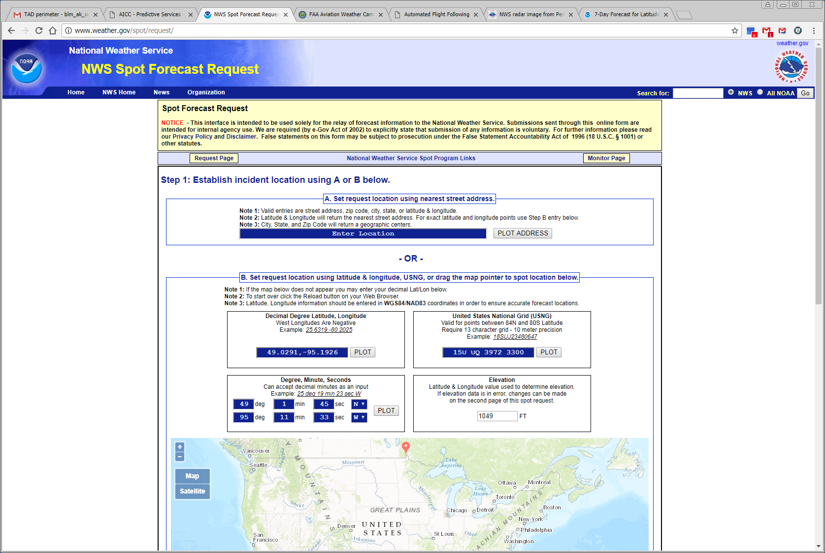
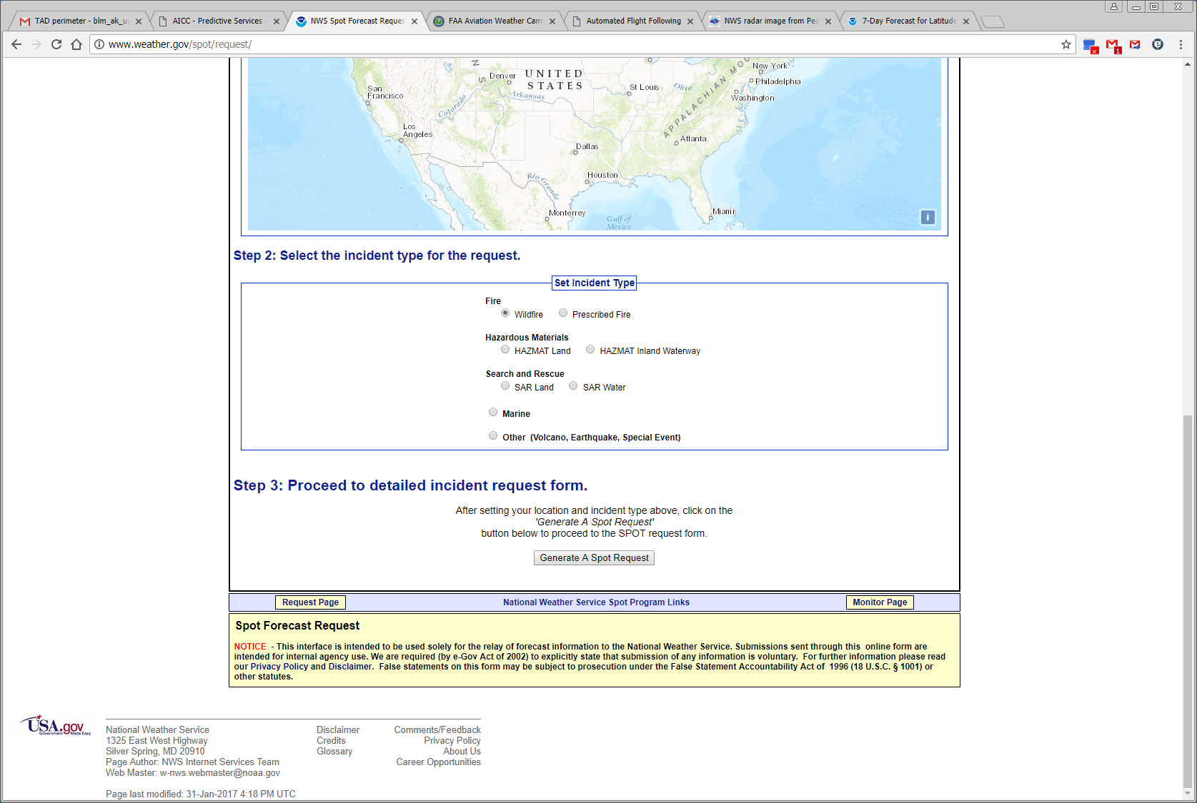
This will take you to the New Spot Request for Incident Page. Fill in the header info, select deliver forecast time, outputs under “Select all periods” and enter observations if available. Select “Submit New Request” and return to the Monitor Page. The status should change to “Pending Request” in green font. 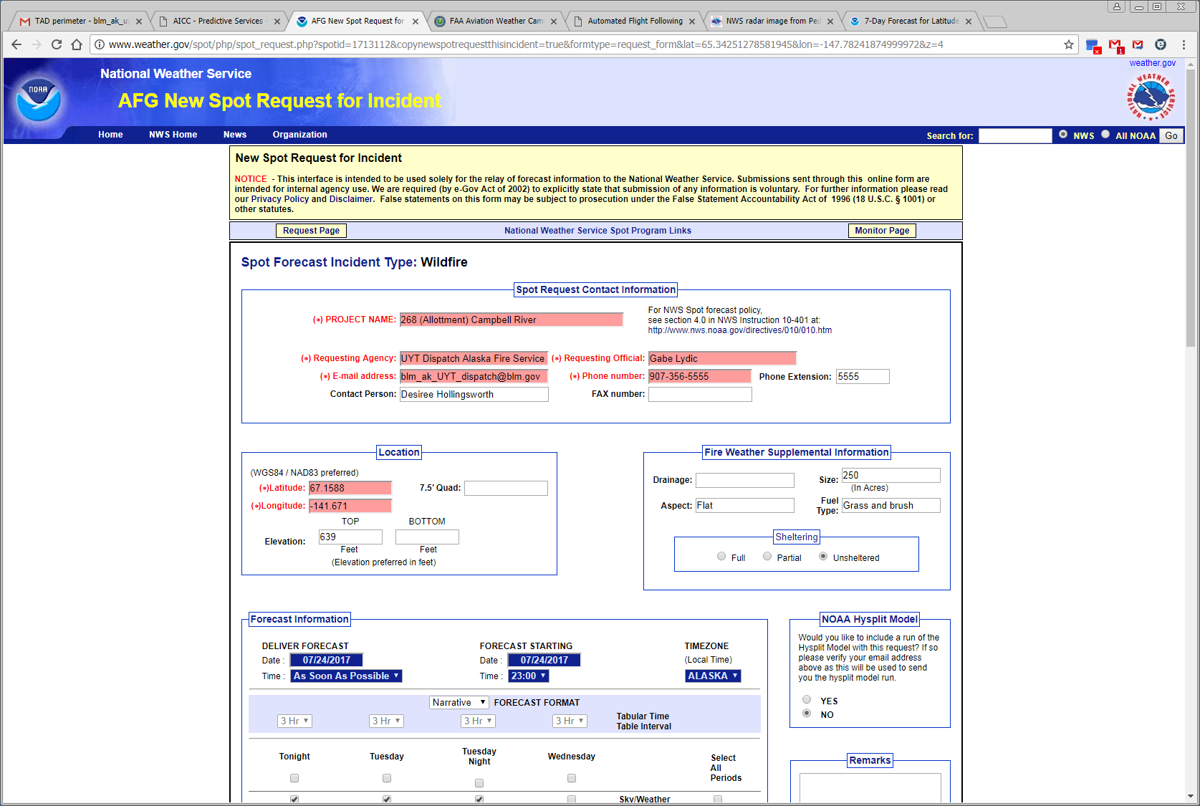
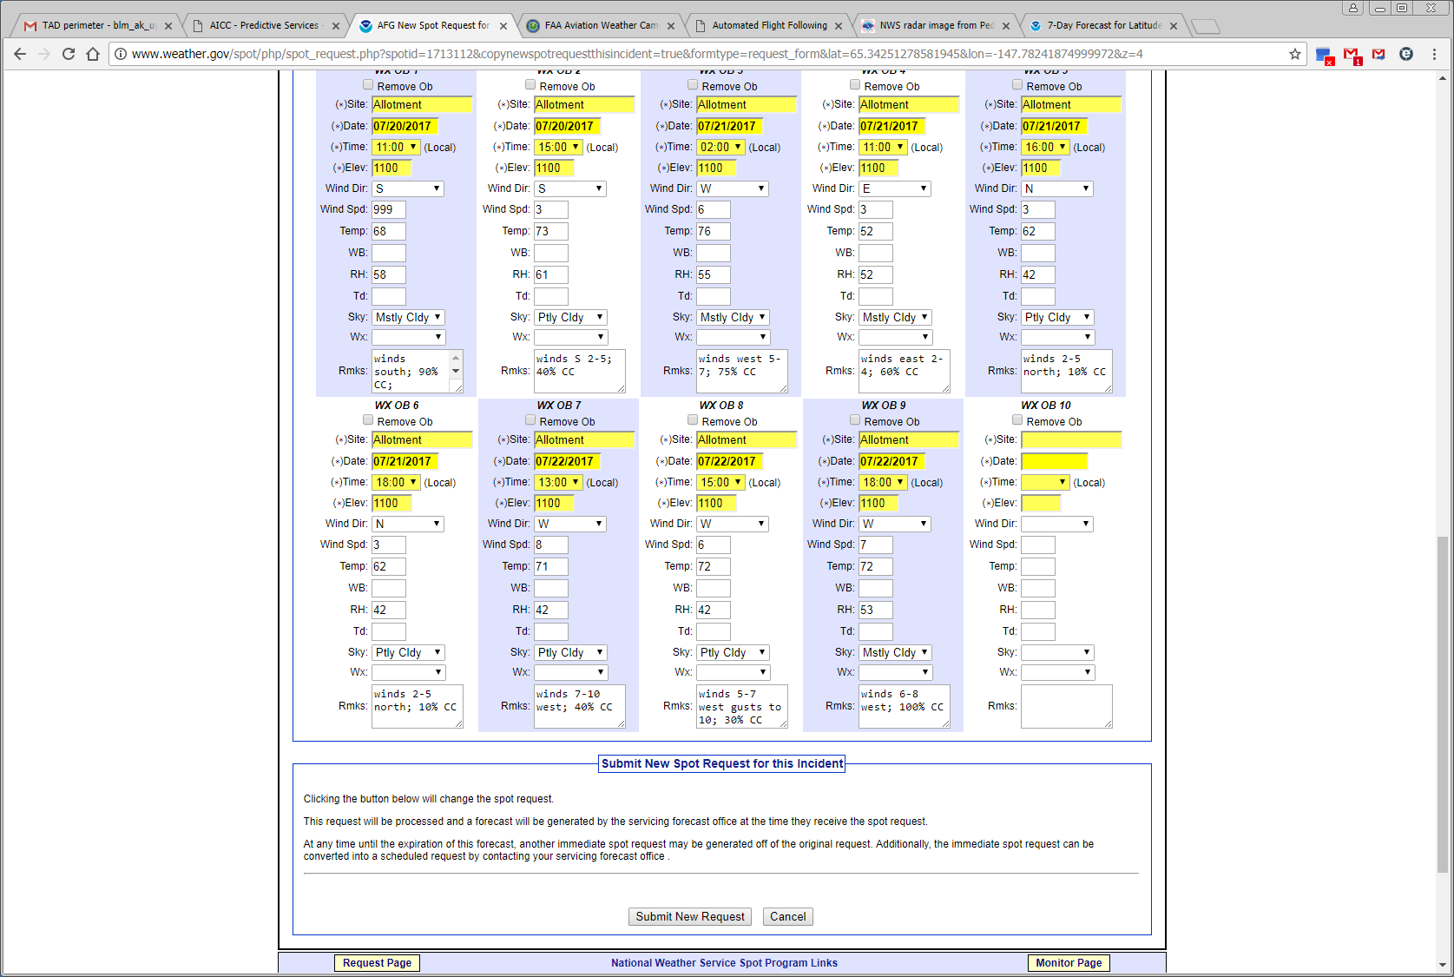
A TIP: Sizing the map to only Alaska will show all of the requests generated for Alaska. To print a completed request, click on the incident name, select “Printer Friendly Version of Forecast” to get the properly formatted report.
This is the spot weather forecast main NWS Spot Forecast Monitor Page. This screen can be used to:
- Submit observations to existing spot weather forecast requests
- Submit new fire spot weather forecast requests
- Make changes to submitted spot weather requests
- Print the spot weather forecast’s cumulative record or individual daily forecasts
- Monitor the status of requests
- Move to the Request Page and create a new incident spot weather request
- Close individual fire spot weather requests

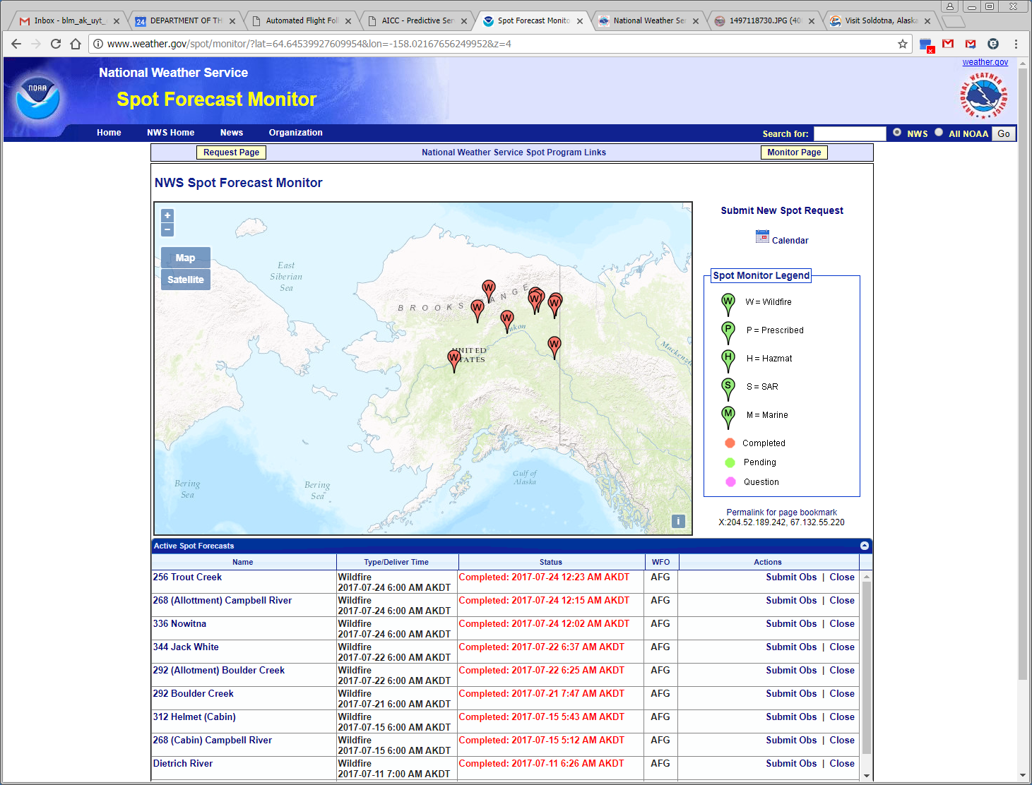

STEP 1: To submit observations on an existing request, click on “Submit Obs” on the Monitor Page. Enter the information into the blocks. If there is more than one observation, click “Add Another Observation” until the last observation has been entered. Select “Submit Observations” to save the data, then “Back to Forecast Monitor” to get back to the Monitor Page. If no observations are available, move to Step 2.

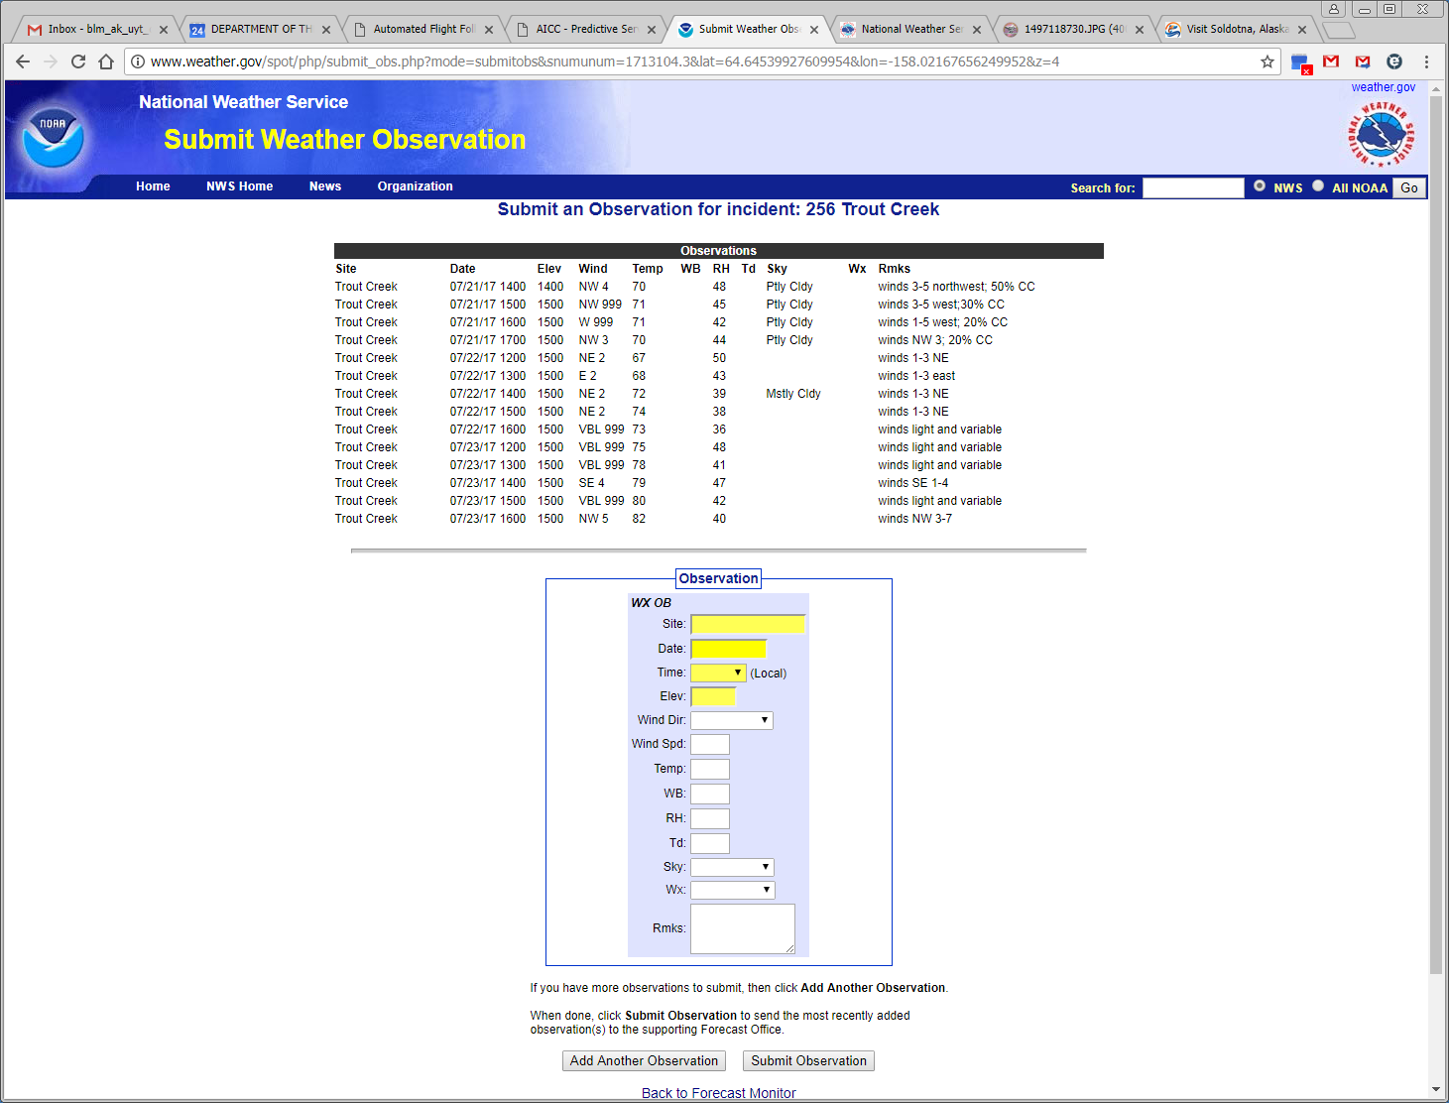

Step 2: Select the name of the incident on the Monitor Page to move to the page showing the map data, all previous observations and the last spot forecast issued by the NWS. 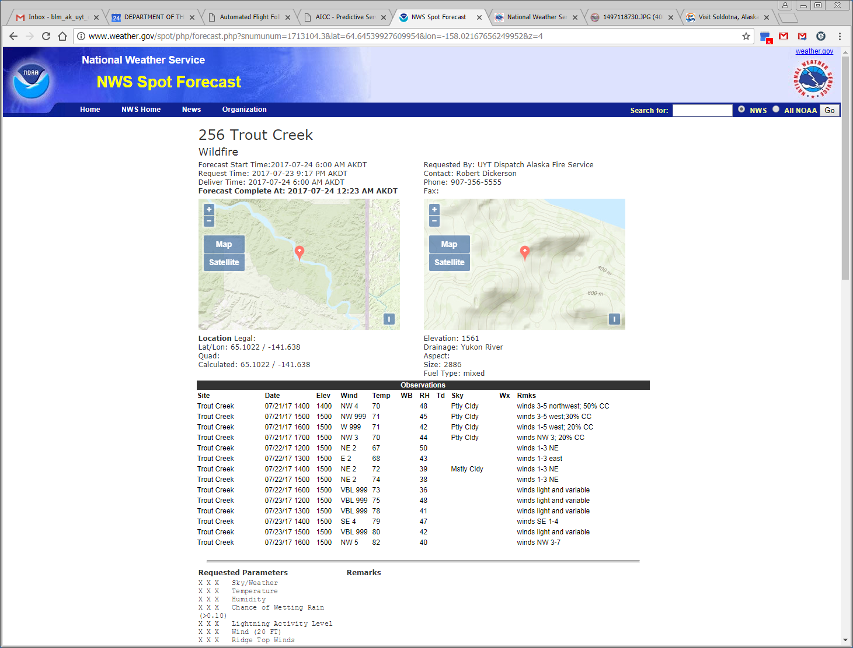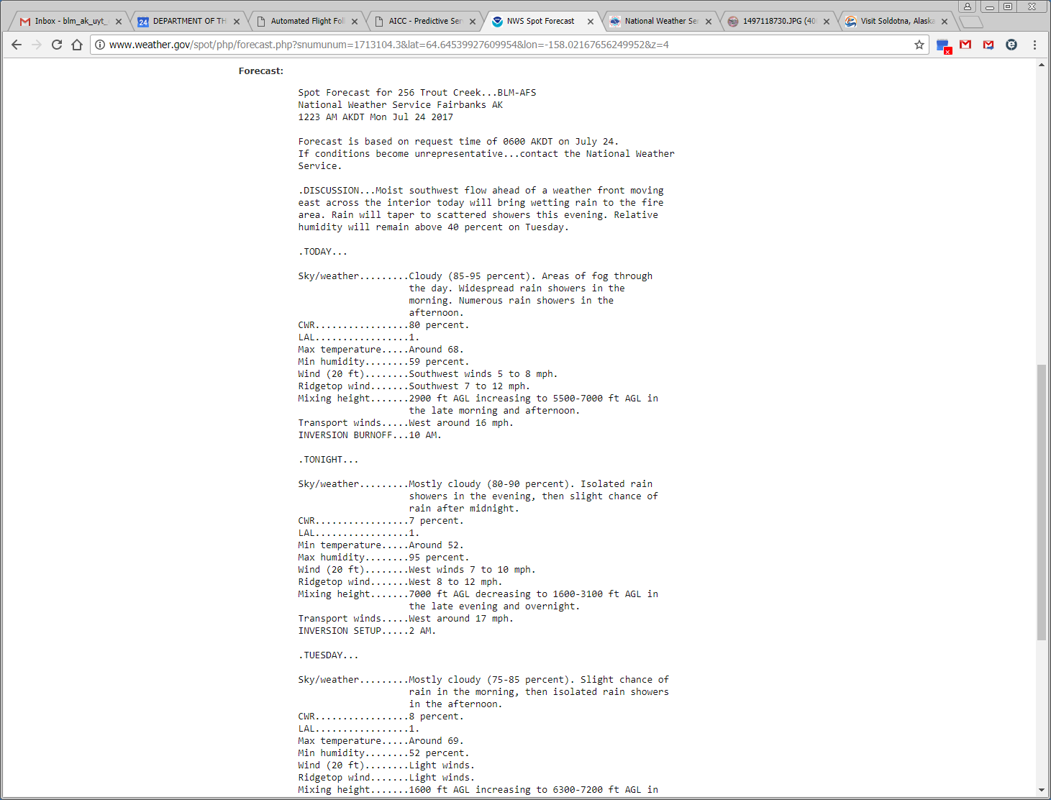
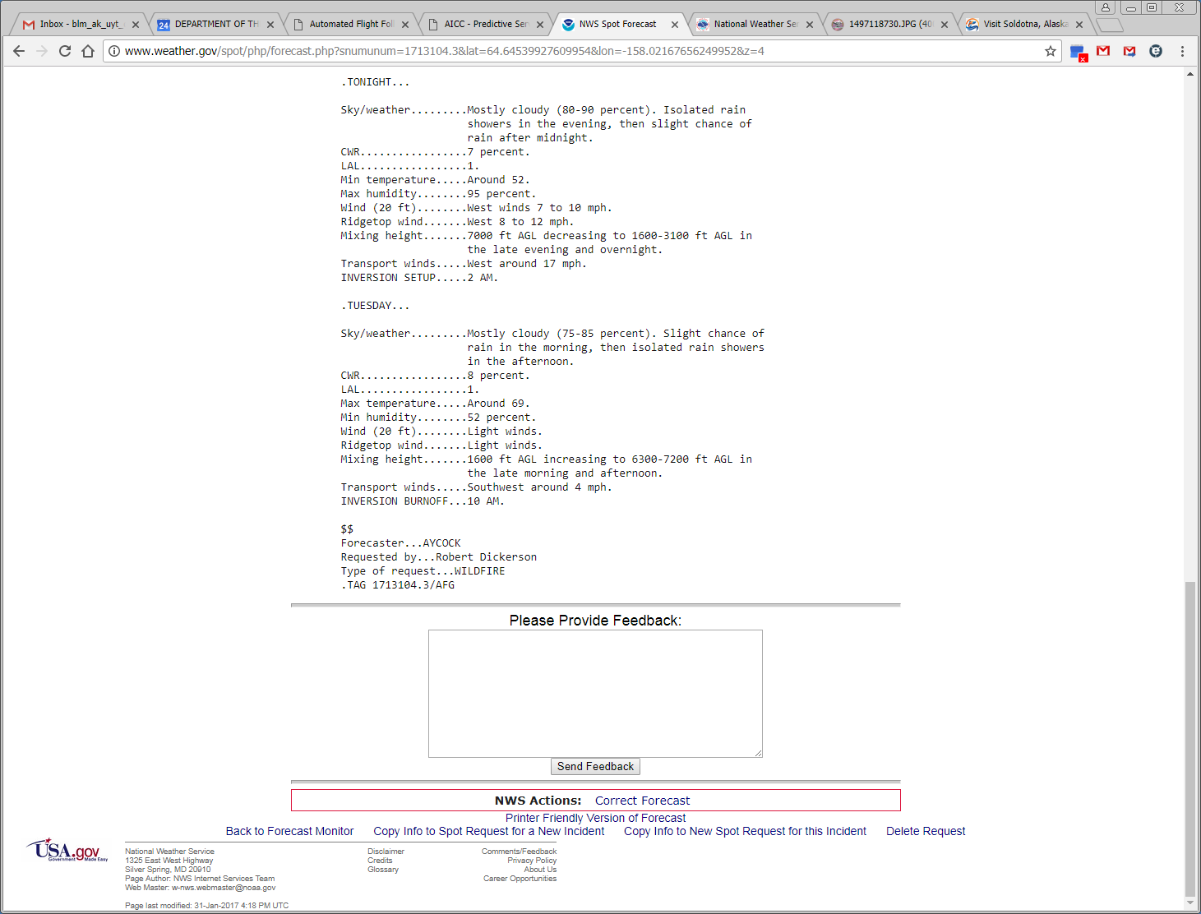

Step 3: Select “Copy Info to a New Spot Request for this Incident”. This will copy all the previous data and take you to the New Spot Request for Incident Screen. Enter data to the “Deliver Data” date and time blocks and select the outputs under “Select all periods” that you want to appear on the spot weather forecast. Edits to the observations can be made also.
Select “Submit New Request” to generate the request and get back to the Monitor Page. The status should change to “Request Pending” in green font under the Status column.
A TIP: Sizing the map to only Alaska will show all of the requests generated for Alaska.
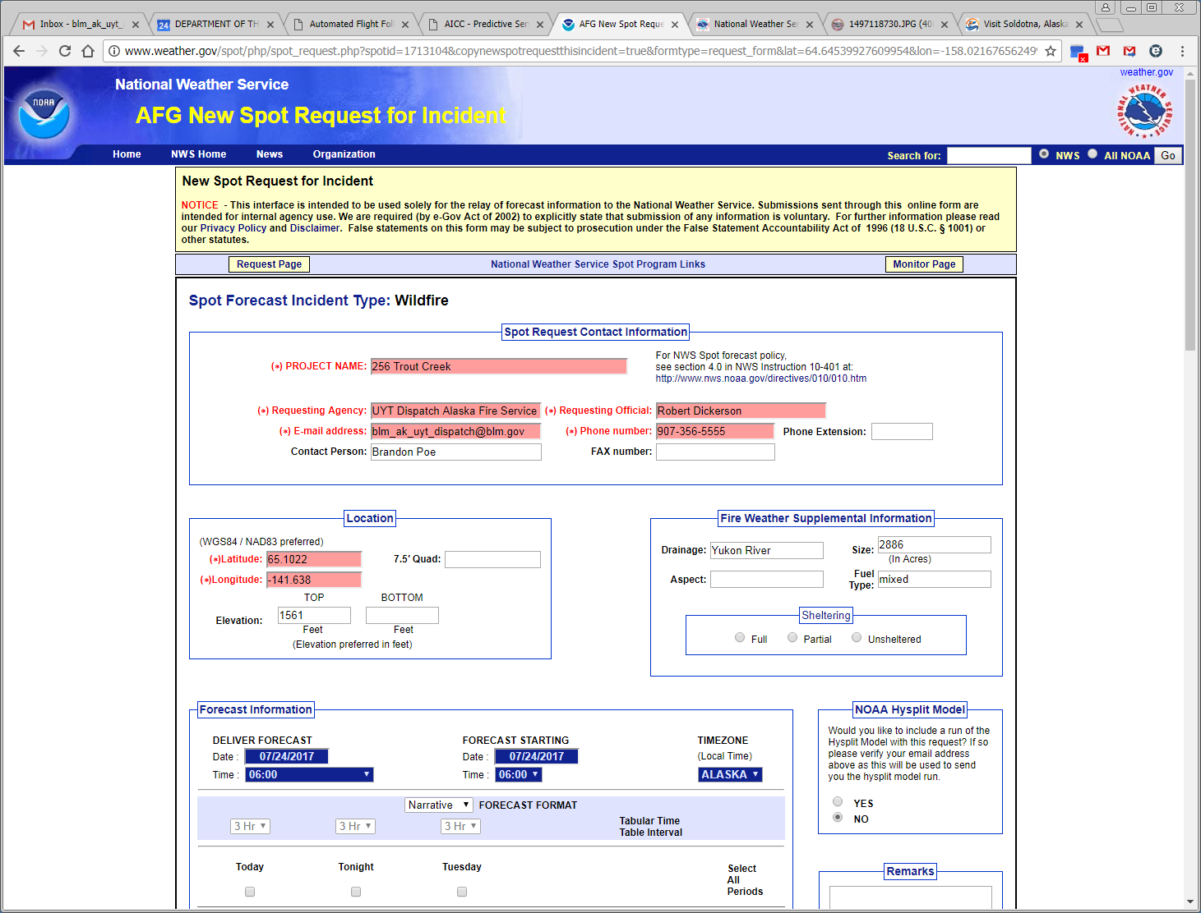
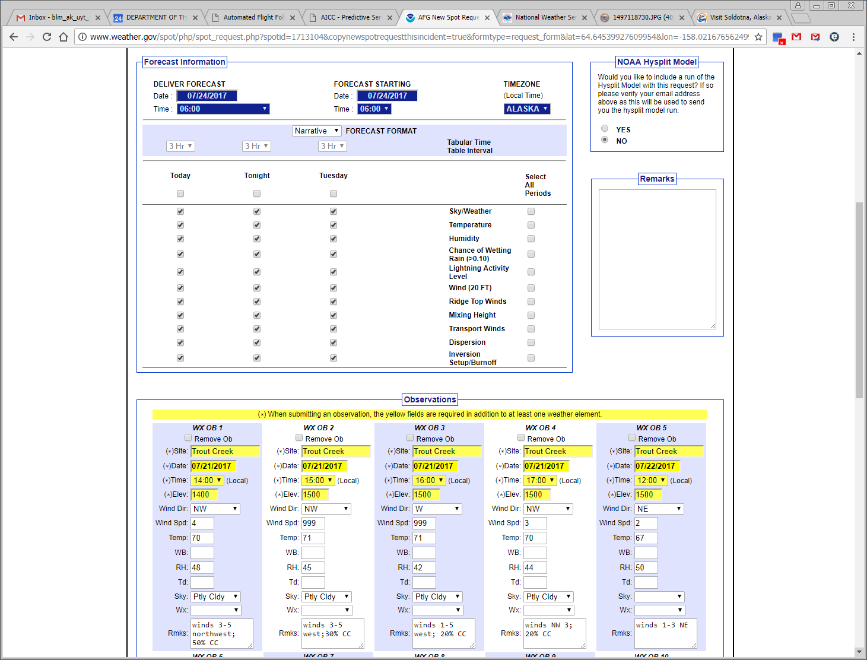
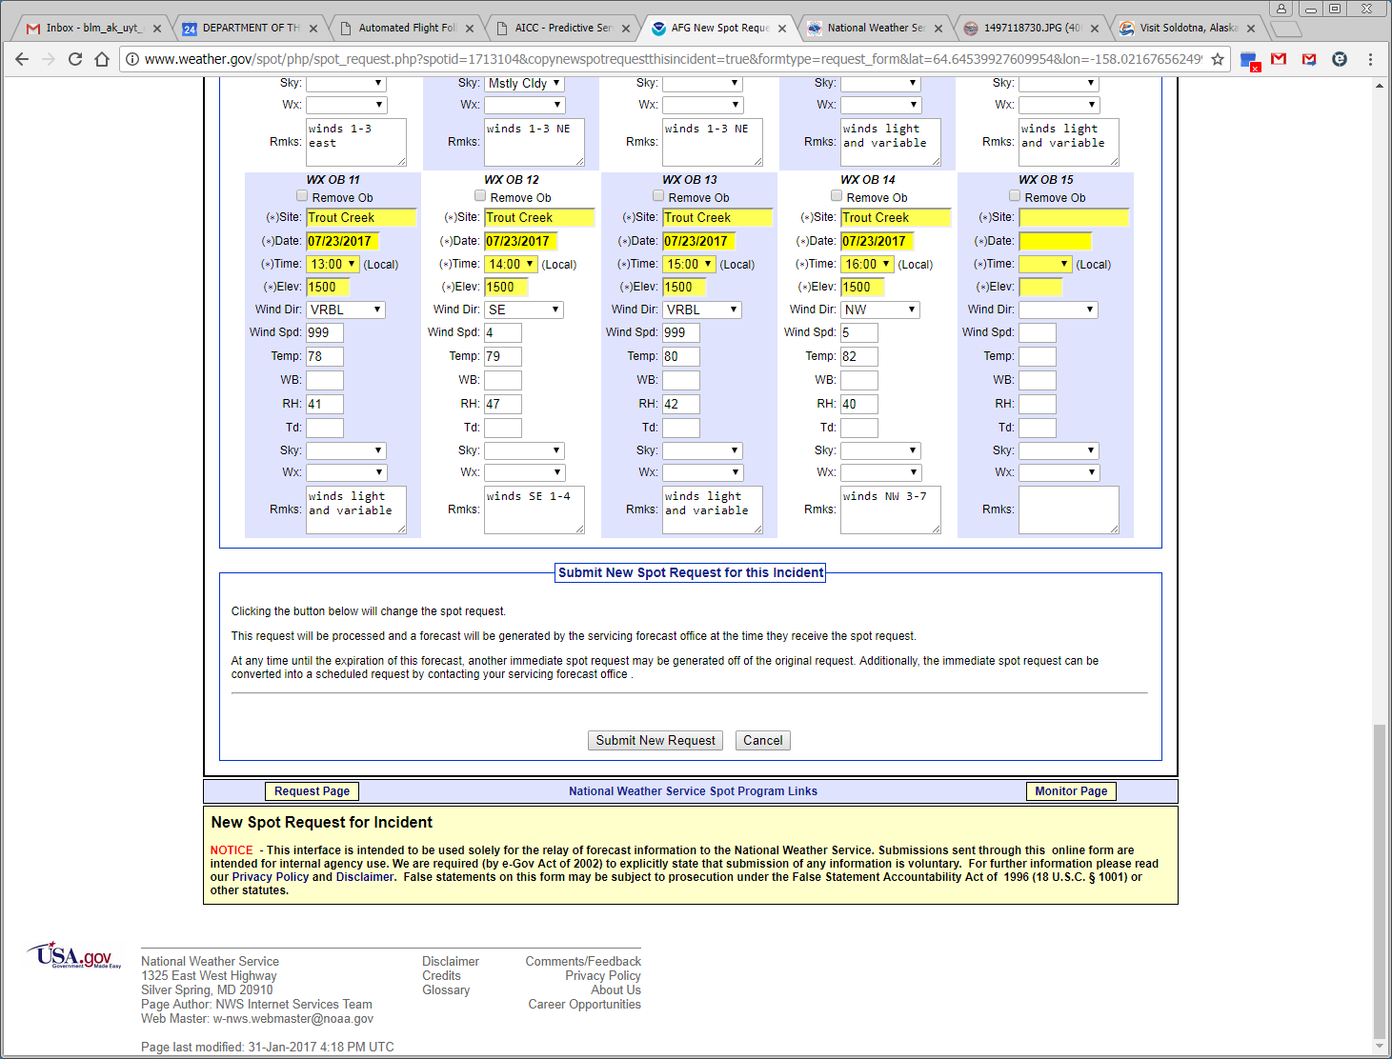
Step 4: To print a completed request, click on the incident name, select “Printer Friendly Version of Forecast” to get the properly formatted report.

